**NORMAL DISTRIBUTION**

1. The amount of mustard dispensed from a machine at *The Hotdog Emporium* is *normally distributed*with a mean of 0.9

ounce and a standard deviation of 0.1 ounce.  If the machine is used 500 times, *approximately*how many times will it

be expected to dispense 1 or more ounces of mustard.

2. Professor Halen has 184 students in his college mathematics lecture class. The scores on the midterm exam are

normally distributed with a mean of 72.3 and a standard deviation of 8.9. How many students in the class can be

expected to receive a score between 82 and 90? Express answer to the nearest student.

3. A machine is used to fill soda bottles. The amount of soda dispensed into each bottle varies slightly. Suppose the

amount of soda dispensed into the bottles is normally distributed. If at least 99% of the bottles must have between 585

and 595 milliliters of soda, find the greatest standard deviation, to the nearest hundredth, that can be allowed.

4. Neesha's scores in Chemistry this semester were rather inconsistent: 100, 85, 55, 95, 75, 100. The population mean and

standard deviation are 85 and 16, respectively. For this population, how many scores are within one standard deviation

of the mean?

5. Battery lifetime is normally distributed for large samples. The mean lifetime is 500 days and the standard deviation is

61 days. To the nearest percent, what percent of batteries have lifetimes longer than 561 days?

6. The number of children of each of the first 41 United States presidents is given in the accompanying table. For this

population, the mean and the standard deviation are 3.6 and 2.9, respectively. How many of these presidents fall within

one standard deviation of the mean?

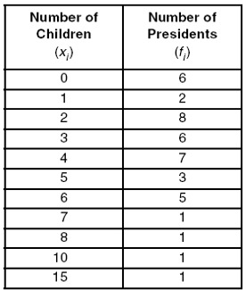

7. A shoe manufacturer collected data regarding men's shoe sizes and found that the distribution of sizes exactly fits the

normal curve. If the mean shoe size is 11 and the standard deviation is 1.5, find:

a. the probability that a man's shoe size is greater than or equal to 11.

b. the probability that a man's shoe size is greater than or equal to 12.5.

c. 

8. Five hundred values are normally distributed with a mean of 125 and a standard deviation of 10.

a. What percent of the values lies in the interval 115 - 135, to the nearest percent?

b. What percent of the values is in the interval 100 - 150, to the nearest percent?

c. What interval about the mean includes 95% of the data?

d. What interval about the mean includes 50% of the data?

9. A group of 625 students has a mean age of 15.8 years with a standard deviation of 0.6 years. The ages are normally

distributed. How many students are younger than 16.2 years? Express answer to the nearest student?

10. Entry to a certain University is determined by a national test. The scores on this test are normally distributed

with a mean of 500 and a standard deviation of 100. Tom wants to be admitted to this university and he

knows that he must score better than at least 70% of the students who took the test. Tom takes the test and

scores 585. Will he be admitted to this university?